PHYSICS

Stage 3

Sample WACE Examination 2010

Marking Key
Marking keys are an explicit statement about what the examiner expects of candidates when they respond to a question. They are essential to fair assessment because their proper construction underpins reliability and validity.
When examiners design an examination, they develop provisional marking keys that can be reviewed at markers’ meetings and modified as necessary in the light of student responses.
This marking key has been developed by examiners in conjunction with the sample examination paper and, as is the case with any external examination developed by the Curriculum Council, is a provisional document that can be modified if necessary in the light of student responses.

Section One: Short response 30% (54 Marks)

This section has 13 questions. Answer all questions. Write your answers in the space provided.

Question 1 (3 marks)

A positively charged metal sphere is located above a negatively charged conducting plate as shown in the diagram. Sketch the electric field lines between the charged sphere and the plate, using the four dots on the sphere as starting points.
- - - - - - - - -
+

Description | Marks
Require 4 lines | 1
Field lines leave +ve perpendicularly and arrive at –ve perpendicularly also | 1
Direction of arrow | 1
 | Total 3

Question 2 (3 marks)

The following diagram shows wavefronts approaching a gap in a barrier.

Barrier

(a) Complete the diagram showing the wavefronts after they pass through the gap.

Barrier

(2 marks)
Description | Marks
Shape circular | 1
Separation [wavelength] same as incident rays. | 1
 | Total 2

(b) Identify the type of wave shown in the diagram above by circling the correct answer.
(1 mark)
Description | Marks
(iii) could be either | 1
 | Total 1

Question 3 (4 marks)

A student is investigating the emf induced along a metal rod moving in the Earth’s magnetic field. The 3.00 m long rod is clamped, vertically upright, to the top of a train and is electrically insulated from the train. The train is moving at 72.0 km h⁻¹ west in a region where the Earth’s magnetic field is horizontal and has magnitude 5.00 × 10⁻⁵ T.

(a) Calculate the value of the induced emf, showing your working. (3 marks)

Description | Marks
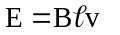 | 1
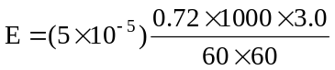 | 1
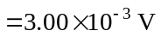 | 1
 | Total 3

(b) Which part of the aerial will develop a positive charge? Circle the correct answer. (1 mark)

(i) top | (ii) bottom | (iii) there is not enough information supplied
Description |  |  | Marks
(ii) Bottom |  |  | 1
 |  |  | Total 1

Question 4 (3 marks)

The resolving power of any telescope defines whether an observer can clearly see two distant stars as two separate images. An angle of 10⁻⁵ radians between two clear images is considered to be the minimum acceptable. This angle is denoted by Φ in the equation

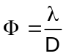

where λ is the wavelength of the radiation received and
D is the diameter of the receiving dish or antenna

An optical telescope with a 10 m diameter dish can collect useful information in the optical range of wavelengths. The proposed Square Kilometre Array radio wave telescope, intended to detect electromagnetic radiation at a wavelength of 21 cm, needs to cover an area of hundreds of square kilometres. Explain this difference.

Description | Marks
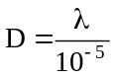 | 1
λ [ SKA ] = 0.21 m λ [ light ] = 5x10⁻⁷m (1) | 1
D [SKA] = 2100 m D [Optical] = 5 x 10⁻² m (1) | 1
Detailed calculations are not required but students must show they appreciate the wavelength of radio waves is about 100 000 times larger than those of light waves so the receiving dish [minimum] must be about 100 000 times bigger
 | Total 3

Question 5 (5 marks)

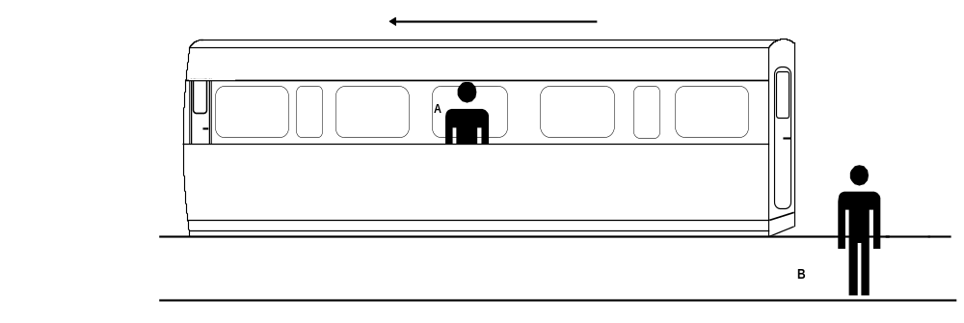
Train moving at very high velocity
B
A

An observer at position A at the midpoint of a train carriage (a moving frame of reference), sends light signals to the front and back of the carriage at the same time. These light beams open doors at each end of the carriage. Another observer at position B is stationary on the platform, watching the train moving away from him at high velocity.

(a) Does observer A see the doors in the carriage open simultaneously, or at different times? (1 mark)

Description | Marks
Both doors opening at the same time | 1
 | Total 1

(b) Does observer B see the doors in the carriage open simultaneously, or at different times? (2 marks)

Description | Marks
B sees door closest to him opening before the door furthest away | 2
If indicates they would make a different observation | 1 only
 | Total 2

(c) If the observations are different, whose observation is correct? Explain your reasoning.
(2 marks)

Description | Marks
Both are correct | 1
One set of simultaneous events are not necessary simultaneous for another observer moving at different speed. | 1
 | Total 2

Question 6 (4 marks)

The force that holds the protons and neutrons together in the nucleus is known as the strong nuclear force. This force only acts on particles known as hadrons of which protons and neutrons are members. Hadrons are thought to be made up of quarks having non integer charges. All hadrons are made of three quarks.

These quarks have different charges. The up quark has a charge of 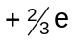 while the down quark has a charge of 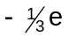. ‘e’ is the charge on an electron.

(a) List the quarks in a proton and justify your answer. (2 marks)

Description | Marks
Proton is u u d | 1
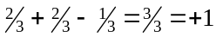 | 1
 | Total 2

(b) List the quarks in a neutron and justify your answer. (2 marks)

Description | Marks
Neutron is u d d | 1
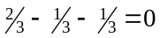 | 1
 | Total 2

Question 7 (4 marks)

In the circuit shown below the lamps are identical to each other. The ammeter reads 1.33 A.

Calculate the resistance of one lamp.

Description | Marks
Apply Ohm’s Law to entire circuit  V = I.R  10 = 1.33 × R  R_{T} = 7.5 Ω | 2
Resistors in parallel  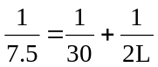where L is the resistance of either lamp | 1
Solve L = 5.00 Ω | 1
 | Total 4

Question 8 (4 marks)

While on holiday in the United States, Max purchased a hair dryer marked

120 V, 1200 W.

(a) If Max wants to use the hair dryer in Australia where the electricity is supplied at 240 V, what power will it draw from the mains? Assume the resistance of the heater coil is constant. (3 marks)
Description | Marks
P= I.V  1240 = I x 120  I = 10 A V = I. R  so 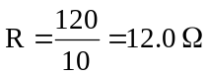 | 2
  note current drawn is 20 A | 1
 | Total 3

(b) Suggest how the hair dryer in (a) could safely operate at its specified power in Australia.
(1 mark)

Description | Marks
Purchase a plug / transformer so 240 V AC => 120 V AC | 1
or Resistor in series, has to be large size to dissipate 3 kW | 1
 | Total 1

Question 9 (4 marks)

A cathode ray oscilloscope contains two parallel plates, AB and CD, with a high voltage (potential difference) across them as shown below.

A
B
100 V DC

C
D

(a) Draw the electric field pattern between the plates AB and CD. (2 marks)

Description | Marks
A B

C D

Direction of arrow and field line | 1
Uniform nature of electric field | 1
 | Total 2

(b) Calculate the electric field intensity if the battery has a voltage of 100 V DC and the plate separation is 2.00 cm. (2 marks)

Description | Marks
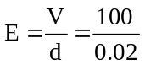 | 1
= 5000 or 5.00 x 10³ V m⁻¹ | 1
 | Total 2

Question 10 (4 marks)

A compact disc spins at 4000 revolutions per minute, and has a radius of 6.00 x 10⁻² m. A dust particle of mass 1.00 x 10⁻⁴ kg rests on the outer edge of the disc. Calculate the magnitude of the frictional force required to prevent the dust particle from flying off the spinning disc.

Description | Marks
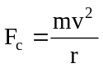 | 1
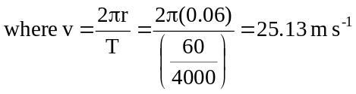 | 1
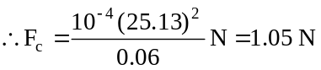 | 2
 | Total 4

Question 11 (4 marks)

A traction device uses three pulleys to apply a horizontal force to a patient’s foot as shown in the figure below. A single string goes around the three fixed pulleys. One end of the string is tied to a 2.50 kg load and the other end is tied to a rigid support. The middle pulley is attached to the patient’s ankle and pulls it as shown. Calculate the magnitude of the force exerted on the patient’s ankle. Assume that the pulleys are frictionless.

35.0°

35.0°
2.50 kg
Support

Description | Marks
Tension = 2.5 x 9.8 = 25 N constant through entire rope. | 2
Resolve horizontally 2T cos 35 = 2 x 25 x 0.82 = 40 N | 2
 | Total 4

Question 12 (3 marks)

An oscillating pendulum has an aluminium plate attached to it that passes between opposite magnetic poles as shown.

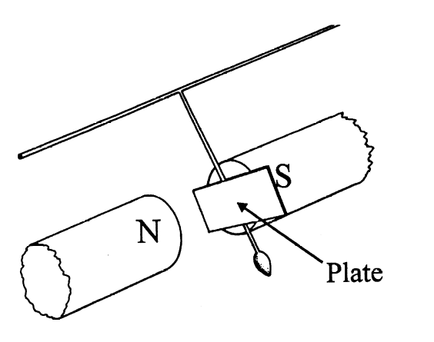

(a) Describe what would happen to the aluminium plate as it swings between the poles.
(2 marks)
Description | Marks
Each time the aluminium disc passes through the field it slows down and it amplitude of oscillation decreases | 2
 | Total 2

(b) How would your observations change if the aluminium plate is replaced with an identically-shaped iron plate? (1 mark)

Description | Marks
If it were iron it would not oscillate but ‘stick’ to the poles of the magnet on first swing | 1
 | Total 1

Question 13 (8 marks)

A metal tube, open at both ends, has a small loudspeaker fitted over one end. The speaker is connected to an audio frequency generator. The note produced by the speaker is altered slowly until resonance is detected.

tube
loudspeaker
to audio frequency generator

(a) Does the vibrating speaker cone act as a displacement node, or a displacement antinode?
(1 mark)
Description | Marks
Node | 1
 | Total 1

(b) Using the axes above, draw a displacement versus distance graph for the standing wave produced at the fundamental frequency. (2 marks)

Description | Marks
Closed at speaker end, open at the other | 1
First harmonic shown | 1
 | Total 2

(c) How would resonance be detected in this case? (1 mark)

Description | Marks
Increased amplitude (loudness) as the resonance point is approached | 1
 | Total 1
(d) If the fundamental resonant frequency is 173 Hz and the speed of sound in the tube is 346 m s⁻¹, calculate the length of the tube. (2 marks)

Description | Marks
Wavelength is 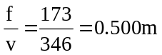 | 1
Tube length is one quarter wavelength = 0.125 m | 1
 | Total 2

(e) How would the resonant frequency change if you used a longer tube? Explain. (2 marks)

Description | Marks
Decreases | 1
As length increases, fundamental wavelength increases so fundamental frequency increases | 1
 | Total 2

End of Section A

Section Two: Problem-solving 50% (90 Marks)

This section has seven (7) questions. You must answer all questions. Write your answers in the space provided.

Suggested working time for this section is 90 minutes.

Question 14 (13 marks)

A survival course requires trainees to retrieve a ration pack of mass 2.00 kg suspended from a rope above a fast flowing river, as shown in the diagram below.
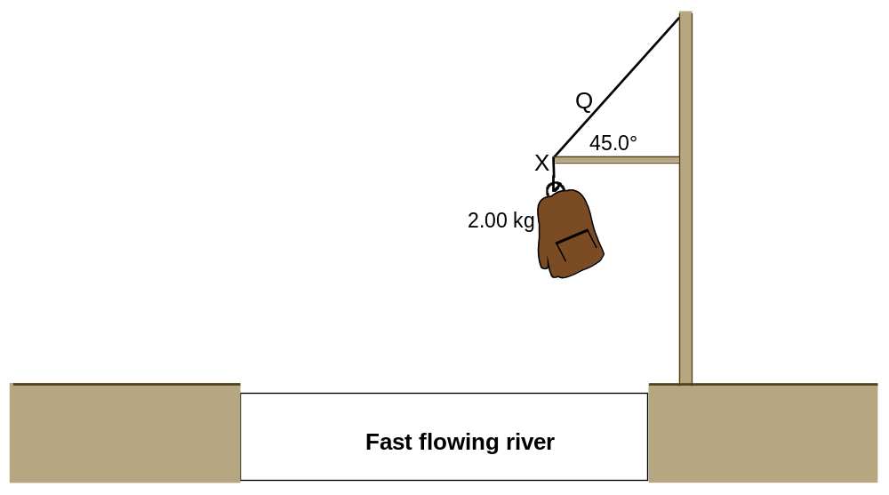

(a) Determine the net force acting on the suspended pack. (1 mark)

Description | Marks
Zero (force up = force down) no explanation required | 1
 | Total 1

(b) On the diagram, draw vectors to represent the forces acting at point X. Ignore any frictional forces that might act at X. (3 marks)

Description | Marks
tension  reaction  weight  Each vector 1 mark, no need to name. | Each vector  1 mark
 | Total 3

(c) Calculate the tension in the rope at the point marked Q. (3 marks)
Description | Marks
Resolve vertically, | 1
T sin 45 = mg | 1
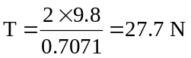 | 1
 | Total 3

(d) Robin, a trainee whose mass is 80.0 kg, is unable to reach the hanging mass. Robin suggests to a friend, Christine, that they could use a 3.00 m long uniform plank of mass
12.0 kg as shown below.
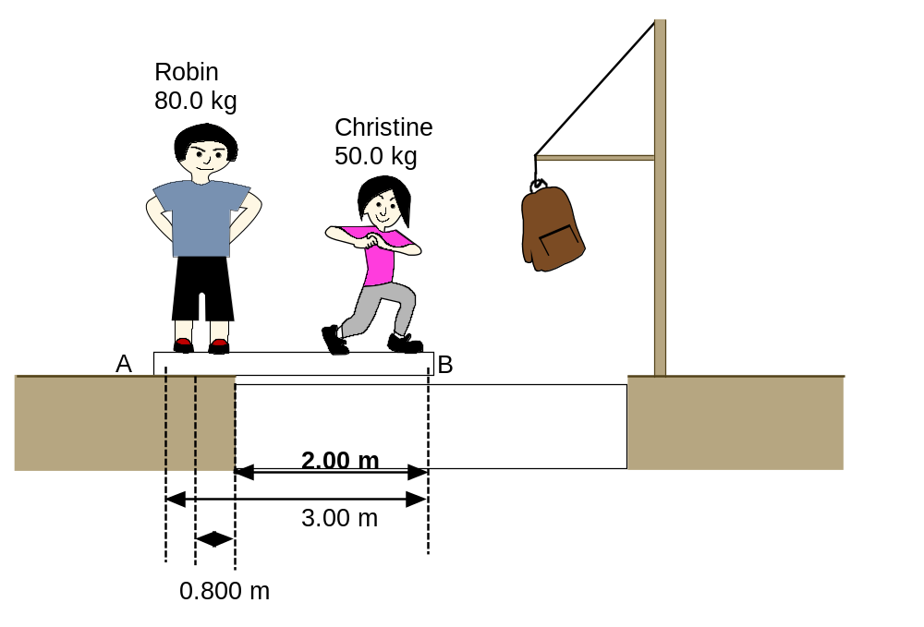
Robin stands so that his centre of mass is 0.200 m from end A of the plank. With Robin holding down one end, the plank extends over the river bank by 2.00 m. Christine, of mass 50.0 kg, walks out along the plank toward end B.

Calculate how far Christine can safely walk along the plank. (6 marks)

Description | Marks
Take moments about C ,  80 × 9.8 × 0.8 = 50 × 9.8 × y + 12 × 9.8 × 0.5  627.2 = 58.8 + 490 y [ y is distance of Christine from C]  y = 1.16 m | 1  2  2  1
 | Total 6

Question 15 (12 marks)

A farmhouse is supplied electricity from a transformer 3.00 km away. The input voltage of the transformer is 50.0 kV and the output voltage of the transformer is 250 V. When an electric heater is used inside the farmhouse the measured voltage across the heater is 220 V. The resistance of the heater is 40.0 Ω.

50 kV
Transformer
250 V


(a) Calculate the turns ratio of the transformer. (1 mark)

Description | Marks
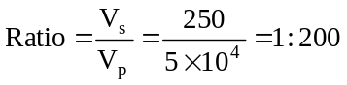 | 1
 | Total 1

(b) Calculate the current to the heater. (2 marks)

Description | Marks
V = I R  220 = I × 40 | 1
I = 5.5 A | 1
 | Total 2

(c) Calculate the power of the heater. (2 marks)

Description | Marks
P = I² × R = [5.5]² × 40 | 1
= 1210 W | 1
 | Total 2

(d) Calculate the resistance of the cables supplying electricity to the farmhouse. (2 marks)

Description | Marks
V = Ix R  250 – 220 = 30 = 5.5 × R | 1
R = 5.45 Ω | 1
 | Total 2

(e) Calculate the amount of energy dissipated as heat in the cables every second.
(3 marks)
Description | Marks
Heat = I² × R | 1
= [5.5]² × 5.45 | 1
= 164.8 W | 1
 | Total 3

(f) A petrol station is further away from the transformer than the farmhouse. Compare the voltage available at the petrol station to the voltage available at the farmhouse. Explain your reasoning. (2 marks)
Description | Marks
Voltage at new farmhouse would be less | 1
because line losses would increase | 1
 | Total 2
Question 16 (15 marks)

The diagram below shows a glass globe containing a heated filament that emits electrons by thermionic emission. Initially, the space inside globe is a vacuum. The electrons are attracted to, and then pass through, a hollow conical anode. This forms a narrow beam of electrons.

The electron beam then enters a region of uniform magnetic field. The magnitude of this field can be changed.

This device can be used for a range of experiments.

(a) Is the anode positively or negatively charged? Explain your answer. (2 marks)

Description | Marks
+ ve charged | 1
required charge to arrtract –ve . charged electrons | 1
 | Total 2

(b) Show clearly on the diagram the trajectory of the electron beam whilst in the uniform magnetic field. (2 marks)

Description | Marks
Shape (curves evenly) | 1
Direction (curves to the right) | 1
 | Total 2

(c) Using the equation 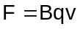 and an equation for circular motion, show that 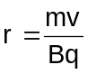. Show your working. (3 marks)

Description | Marks
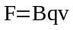 and 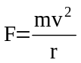  r | 1
So 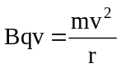 | 1
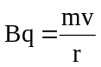  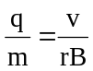 | 1
 | Total 3

(d) One experiment using this apparatus gives the following experimental measurements:
electron speed = 2.00 × 10⁷ m s⁻¹
magnetic field strength = 1.20 × 10⁻³ T
radius of electron path = 10.0 cm.
Use these values to calculate the charge to mass ratio 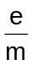 for an electron. (4 marks)
Description | Marks
 | 1
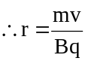 | 1
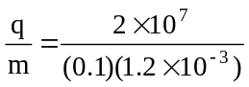 | 1
= 1.66 x 10¹¹ C kg⁻¹ | 1
 | Total 4

(e) If the glass bulb is filled with neon gas, a glowing pink ring appears within the globe when the electron beam is turned on. Explain why this glowing ring appears. (3 marks)

Description | Marks
Electrons collide with the gas atoms | 1
This ionises the gas | 1
Its emission spectrum has a bright pink line | 1
 | Total 3

(f) Suggest how could the colour of the glowing ring could be changed. (1 mark)

Description | Marks
The colour can be changed by changing the gas | 1
 | Total 1

Question 17 (14 marks)

The diagram below shows some of the possible electron energy levels in a hydrogen atom.
The ionisation energy for a hydrogen atom is 13.6 eV.
n = 3
n = 4
n = ∞
E (eV)
-3.39
-1.51
-0.88
0
n = 2
levels
sub-levels
Ground state

_________

(a) Mark the value of the ground state of hydrogen in the box labelled ‘ground state’.
(1 mark)
Description | Marks
13.6 eV | 1
 | Total 1

(b) Explain what is meant by the term ‘ionisation energy’. (2 marks)
Description | Marks
The ionisation energy is the energy to allow the most bound electron to escape the attraction of the nucleus, | 2
 | Total 2

(c) Light from a hydrogen discharge tube can be seen as a line emission spectrum. Using a labelled diagram, describe what a line emission spectrum looks like. (3 marks)
Description | Marks
wavelength  Lines are sharp, coloured, unique to a particular atom, not evenly distributed | 3
 | Total 3
The diagram on page 22 is based on the Bohr model, which is the simplest model of the hydrogen atom. In more physically accurate (and more complex) models the n = 2 energy level is split into two sub-levels. An electron making a transition between these sub-levels emits a photon with a wavelength of 21 cm.

(d) Calculate the energy difference (in eV) between the two n = 2 sub-levels. (3 marks)
Description | Marks
E = h f | 1
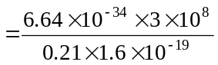 | 1
= 5.92 x10⁻⁶ eV | 1
 | Total 3

This 21 cm wavelength in the hydrogen spectrum is used by radio astronomers to measure the velocities of stars and galaxies.

(e) Describe the difference you would expect to see between a hydrogen spectrum emitted by a galaxy that is not moving toward or away from our galaxy, and a hydrogen spectrum emitted by a galaxy moving away from our own. (2 marks)

Description | Marks
The entire frequency spectrum would be shifted, on a horizontal axis representing wavelength, toward the right i.e. each line would have a (slightly) increased wavelength. | 2
To say “red shifted” is too vague for full marks – 1 mark at most
 | Total 2

(f) How does your answer to (e) provide evidence for the Big Bang model of the formation of the Universe? (3 marks)
Description | Marks
By measuring the shift in wavelengths or frequencies scientists can measure the speed of distant galaxies | 1
They discovered that the further away a galaxy was, the greater the frequency shift (red shift) so the Universe was | 1
Extrapolating backwards we see that a long time ago (13 billion years) the Universe was very, very much smaller | 1
 | Total 3

Question 20 (15 marks)

During a cricket match a cricket ball is hit with an initial velocity of 45.0 m s⁻¹ at an angle of 30.0º to the horizontal from a height of 1.10 m above the ground. It lands in the spectators' balcony which is 8.50 m above the ground.


balcony
1.10 m
8.50 m

(Diagram not to scale)

(a) Calculate the horizontal and vertical components of the cricket ball’s initial velocity.
(2 marks)
Description | Marks
horizontal velocity = 45 cos 30 = 39.0 ms⁻¹ | 1
vertical velocity = 45 sin 30 = 22.5 ms⁻ | 1
 | Total 2

(b) Determine the final vertical displacement of the ball. (1 mark)
Description | Marks
8.5 – 1.1 = 7.4 m | 1
 | Total 1

(c) Calculate the vertical velocity component of the ball when it lands in the spectators' balcony. (3 marks)
Description | Marks
v² = u² + 2 g s | 1
= [22.5]² - 2x 9.8.x7.4  = 506 – 145 = 361 | 1
v= 19.0 m s⁻¹ | 1
 | Total 3

(d) Calculate the time of flight of the ball. (3 marks)
Description | Marks
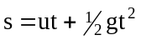 | 3
7.4 = 22.5 t -4.9 t²
4.9 t² - 22.5 t + 7.4 = 0
t = 4.23 s
 | Total 3

(e) Calculate the horizontal distance between the batsman and the point where the ball landed on the spectators' balcony. (2 marks)

If you are unable to complete (d) use value of 4.10 s for time of flight for this question.

Description | Marks
distance horizontally = 39 x 4.23 = 165 m | 2
 | Total 2

(f) Calculate the maximum height the ball achieved relative to the ground. (4 marks)
Description | Marks
v² = u² + 2 g s | 1
0= [22.5]² - 2 × 9.8 × s | 1
s = 25.8 m | 1
Relative to cricket surface = 25.8 + 1.1 = 26.9 m | 1
 | Total 4

Question 19 (10 marks)

A satellite of mass m follows a circular orbit around the Earth, at constant speed and at an altitude h above the Earth’s surface as shown below.
m
h

(a) Determine the orbital period of the satellite if it appears stationary above a fixed point on the Earth’s equator. (1 mark)
Description | Marks
24 hours (so is synchronous with the earth’s orbit time) | 1
 | Total 1

(b) Calculate the height h of the satellite above the surface of the Earth. (6 marks)

Description | Marks
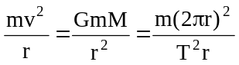 | 1
therefore G M T² = 4 π² r³ | 1
6.67 x 10⁻¹¹ x 5.98 x 10²⁴ x [24x60x60]² = 4 π² r³ | 1
r ³ = 7.54 x 10²² r = 4.22x 10⁷ m | 1
height above earth = 4.22x 10⁷ ⁻ 6.37 x 10⁶ = 3.58 x10⁷ m | 1
 | Total 5

(c) If the mass of the satellite is doubled, how will this affect its orbital radius? Give a reason for your answer. (2 marks)
Description | Marks
Makes no difference, because in the formula 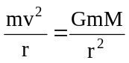the masses (m) cancel | 2
 | Total 2

(d) Name one use or application of geostationary satellites. (1 mark)
Description | Marks
Geostationary satellites are used for communication (1) | 1
 | Total 1

Question 18 (11 marks)

A student is conducting an experiment to investigate the properties of generators. She rotates a coil in a magnetic field as shown and, using a computer data-logger, generates a graph of the output emf from the coil versus time. The experimental arrangement and her graph of the output emf are shown below.

Experimental arrangement (diagram and photograph):
N
S



Graph of the emf generated versus time:

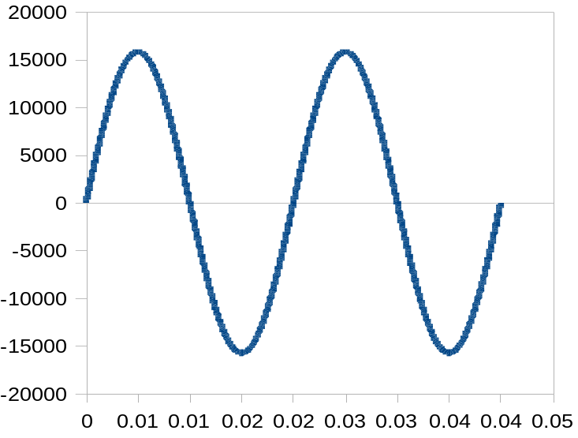
emf (mV)
time (s)
Figure 1

0.01
0.02
0.03
0.04
0.05
0.06
0.07
0.08
0.09

(a) Explain why an emf is generated in the coil. (3 marks)
Description | Marks
Coil ‘cuts’ magnetic field lines | 1
Electrons experience a force | 1
Induced current produced in the coil | 1
 | Total 3

(b) Explain why the graph of the output voltage takes the form shown. (2 marks)
Description | Marks
Rate of cutting field lines is not constant , when coil is vertical (in diagram) then the induced voltage is zero | 1
Direction of the induced voltage changes with rotation | 1
 | Total 2

(c) To increase the output from the generator, the coil can be wound on a material that becomes magnetic in the presence of a magnetic field but loses its magnetism when the field is removed. Explain why it is better to use this type of material rather than a material that can become a permanent magnet. (2 marks)

Description | Marks
The soft iron core concentrated the magnetic field in the coil so increasing the induced voltage | 1
If a ferromagnetic was used the rotor would be attracted to the magnets N-S poles and the coil would not spin | 1
 | Total 2

(d) The student then makes some changes to her experiment and produces the two graphs of output emf versus time as shown below. For each graph, describe one change she could make to her original equipment to produce the output emf shown. (4 marks)
0
0.01
0.02
0.03
0.04
0.05
0.06
0.07
0.08
-40000
-30000
-20000
-10000
0
10000
20000
30000
40000
0.09

emf (mV)

Figure 2

time (s)
Description | Marks
Double field strength or double number of turns | 1
 | Total 1

0
-40000
-30000
-20000
-10000
0
10000
20000
30000
40000
0.01
0.02
0.03
0.04
0.05
0.06
0.07
0.08
0.09

time (s)
emf (mV)
Figure 3

Description | Marks
Double rotation rate | 1
 | Total 1

End of Section B

Section Three: Comprehension 20% (36 Marks)

This section contains two (2) questions. You must answer both questions. Write your answers in the space provided.

Question 21 (18 marks)

Black Holes

Anything on the surface of a large body (for example a planet) is affected by the gravitational field surrounding that body and to escape from the surface an object must move very quickly. The force of gravity will slow such an object but providing it is moving fast enough it can escape, that is, move sufficiently far away from the large body that the gravitational pull never manages to slow the escaping object’s velocity to zero.

The minimum velocity needed to leave a surface is called the escape velocity and the equation used to calculate it is
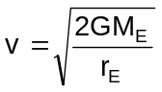
Imagine all the matter of the Sun, a ball of gas (mainly hydrogen and helium) with radius
6.96 x 10⁸ m, squeezed together, so that it has a radius of only 2420 km. The Sun would now be a 'white dwarf' and its gases would have become a mixture of atomic nuclei and loose electrons.

Compressing the Sun even more would cause the electrons to fuse into the nuclei leaving nothing but neutrons. The Sun would be a 'neutron star' with a radius of 7250 m. The escape velocity of a neutron star is 1.93 x 10⁸ m s⁻¹. It is hard to imagine anything being able to achieve such huge velocities but light would be able to escape since it travels at 3 x 10⁸ m s⁻¹.

If the Sun continued to shrink past the neutron star stage the escape velocity would increase, eventually, to the speed of light. Then nothing, not even light, would be able to escape from the Sun’s surface. Anything can fall into such an object, but nothing can escape. It is a 'black hole'.

The critical radius at which a neutron star becomes a black hole is given by the formula
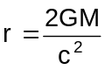
In fact our Sun is too small to become a black hole. Stars more massive than the Sun explode before they begin to collapse, losing some of their mass. If the amount of mass remaining after such an explosion is more than 3.2 times the mass of our Sun, the collapsing star will become a black hole.

Black holes are difficult to detect. They neither emit nor reflect light, are very small and are very long distances from our own planet. The only way we can detect a black hole is to watch out for something falling into it. In general, objects falling toward black holes emit X-rays. If a black hole has a lot of matter falling into it there will be lots of X-rays emitted – enough for astronomers to detect.

The first black hole to be detected was Cygnus X-1. Initially, an X-ray source detected in the constellation Cygnus was found to be close (in astronomical terms) to the star HD-226868, a giant star 30 times more massive than the Sun. HD-226868 is one component of a binary star system. These two stars orbit their centre of mass every 5.6 days. The X-rays come from the other star, named Cygnus X-1.

The motion of HD-226868 shows that Cygnus X-1 is 5 to 8 times the mass of our Sun. A normal star of this mass should be visible with an optical telescope at that distance. However, no optical telescope has ever detected a star in the spot where the X-rays come from. Since Cygnus X-1 has at least 5 times more mass than the Sun, it is too massive to be anything other than a black hole.

(a) Calculate the escape velocity from the Earth. (3 marks)
Description | Marks
 | 1
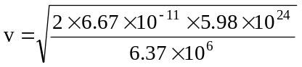 | 1
v= 1.12 x 10³ m s⁻¹ | 1
 | Total 3

(b) Describe how the strength of the gravitational field changes as you move further away from a planet. (2 marks)
Description | Marks
As you move further away from a planet the strength of the gravitational field weakens. As you double the distance the strength of the field falls to ¼. | 2
 | Total 2

(c) Calculate the radius of a black hole having the same mass as the Sun. Using this radius, calculate the density of the black hole. Assume that the black hole is spherical and that its density is given by mass divided by volume. The volume of a sphere is given by
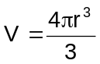 (4 marks)
Description | Marks
Radius =  =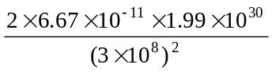  = 2.95x 10³ m | 2
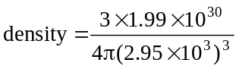  = 1.85 x10¹⁹ kg.m⁻³ | 2
 | Total 4

(d) The X-rays emitted from Cygnus X-1 had wavelengths in the range 10─150 nm. Calculate the energy of a 10 nm X-ray photon. (3 marks)

Description | Marks
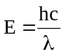 | 1
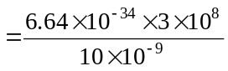 | 1
= 2.0 x 10⁻¹⁷ J | 1
 | Total 3

(e) Is the centre of mass of the binary star system closer to Cygnus X-1 or to HD-226868?. Justify your answer. (3 marks)
Description | Marks
HD – 226868 has a mass 30 × the Sun, Cygnus X-1 has mass approx 5-8 times mass of Sun | 1
centre of mass is likely to be approximately ¾ of the way along the line from Cygnus to HD (ie much closer to HD) | 1
because HD is much bigger | 1
 | Total 3

(f) HD-228686 is continually losing mass at an estimated rate of 2.5 × 10⁻⁶ solar masses per year, creating a stellar wind. Calculate how long it will take HD-228686 to lose a mass equivalent to the mass of the Sun. (3 marks)

Description | Marks
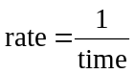 | 1
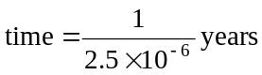 | 1
= 4 x 10⁵ years | 1
 | Total 3

Question 22 (18 marks)

When source of waves moves, the waves it emits change frequency relative to a stationary observer. This applies to both transverse and longitudinal (sound) waves. As a car moves away from you the frequency of the sound you hear is lower than the frequency it is emitting. A similar effect using radar waves is used by police to measure the speed of cars.

Thus if a source of electromagnetic waves such as a star is moving away from an observer on Earth then the frequencies of the lines in the star’s emitted electromagnetic spectrum are shifted to lower values. This is known as red shift.

In 1920, Edwin Hubble measured the red shifts of several galaxies and discovered that most galaxies are moving away from the Earth, suggesting that the Universe is expanding. Hubble also found that the further away a galaxy is, the larger its red shift; that is, the faster it is moving.

The following data together with the associated errors were recorded by Hubble at Mount Wilson in California in the 1940s using an optical telescope.

Object name | Speed of recession  (× 10⁴ km s⁻¹) | Distance  (× 10⁶ light years)
Virgo | 0.2 ± 0.1 | 10.2
Corona Borealis | 2.4 ± 0.2 | 400
Hydra | 6.2 ± 0.3 | 1100
Kip | 4.8 ± 0.2 | 900

(a) Graph this data on the graph paper below, including error bars. Plot recession speed
(y-axis) against distance (x-axis) and draw a line of best fit. (5 marks)
Description | Marks
Graph axes labelled correctly | 2
Points plotted correctly | 1
Error bars include to size | 1
Line of best drawn thru 0,0 | 1
 | Total 5

(b) Use the graph to predict the recession speed of a galaxy that is 710 × 10⁶ light years from Earth. (2 marks)
Description | Marks
Evidence they have used graph to predict the recession speed | 1
Value 4 × 10⁷ m s⁻¹ | 1
 | Total 2

(c) Hubble’s Law can be stated as

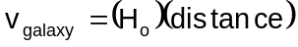

where the term H_{o} is called Hubble’s constant.

Use your graph to calculate a value for H_{o}. Take care with the units. (4 marks)

Description | Marks
Gradient of graph= 4 × 10⁷ m s⁻¹  H_{o}= 5.6 × 10⁻² m s⁻¹ Ly⁻¹ | 2  2
(allow range of answers 4.5 to 6.5 due to line of best fit)
 | Total 4

(d) The shift in wavelength Δλ due to recession of a spectral line of wavelength λ is given by the formula
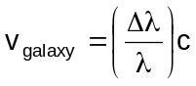
where c is the speed of light, 3 × 10⁸ m s^{-1.}

A line in the spectrum of ionised calcium has wavelength 393.3 nm when measured in the laboratory. When similar light from the elliptical galaxy NGC 4889 is measured its wavelength is 401.8 nm.

Determine the recession speed of this galaxy. (3 marks)
Description | Marks
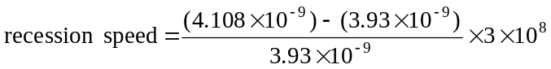 | 2
= 6.48 × 10⁶ m s⁻¹ | 1
 | Total 3

(e) Edwin Hubble could estimate the age of the Universe from his data by calculating the time for which one of the galaxies has been receding. Determine Hubble’s value for the age of the Universe by using the data for Corona Borealis. (4 marks)

Description | Marks
1 light year = 3 ×10⁸ × 365 × 60 × 60 × 24 = 1.58 × 10¹⁵ m | 1
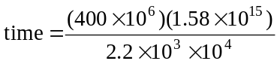 | 2
= 1.37 × 10⁸ years | 1
 | Total 4

ACKNOWLEDGEMENTS

Question 21 Text adapted from: Asimov, I. (1995). Black holes. In J. Carey (Ed.), The Faber book of science (pp. 420–422). London: Faber & Faber.

Question 22 Astronomical data source: Serway, R., Beichner, R., & Jewett, J. (2000). Physics for scientists and engineers (5th ed.). Philadelphia: Saunders College Publications, p. 1541.

